ONLINE ORDERING

HOW TO ORDER YOUR RESOURCES ONLINE
You can order all of your booklist requirements online in 6 simple steps.
- Go to www.campion.com.au and click the red ‘Parents Order Here’ button.
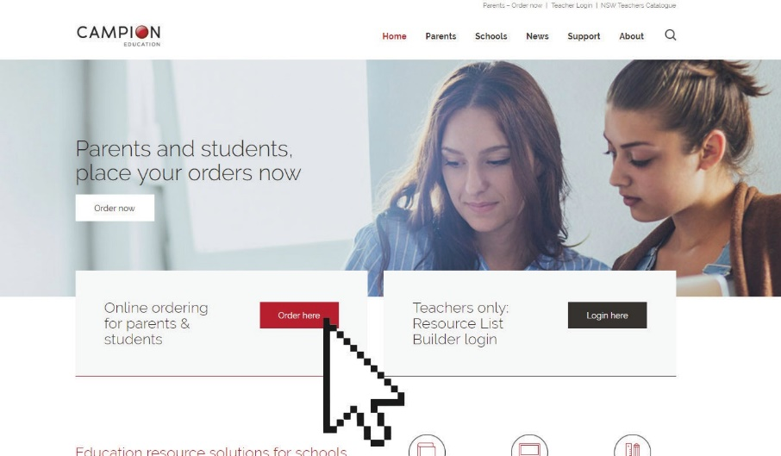

- Create a Campion Education account in less than 1 minute, or sign in using your existing username and password.
- Enter St Joseph’s College, Geelong Resource List code: WHTJ
- Select the Year level and then the resources you need and complete your details.
- Select your delivery method as the following:
  - Economy Delivery – delivered to your chosen address by 25th January 2024.
  - $12.00 Fixed Delivery charge is for ALL orders placed online by Wednesday 13th December 2023
Note: Home Delivery orders must be prepaid at the point of ordering
- Submit your payment.
Done!

For more information and instructional videos, go to: www.campion.com.au
campion.com.au

